70 Indoor Activity Ideas for Teens

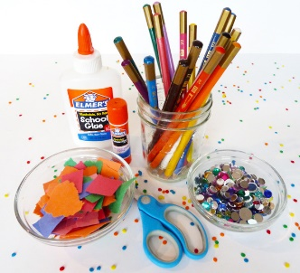
Arts and crafts – Have a look through the existing arts/crafts materials you might have at home. Make pressed flower cards, a collage, dreamcatchers, bracelets, necklaces, wall décor, collect quotes that inspire you. Order more online if needed such as K-Mart: https://www.kmart.com.au/category/toys/toys-by-category/shop-all-toys/kids-art,-craft-&-stationery/252011

Astronomy – Learn all about constellations and the planets: http://astronoteen.org/

Audiobooks – Listen to your favourite book through Audible (https://www.audible.com.au/) or download apps such as “Open Culture,” “Lit2Go”, “Loyal Books”.

Balloon volleyball - Blow up a balloon and clear some space for a competitive game of balloon volleyball. If you don't have anyone to play with, see how many times you can hit the balloon into the air without it touching the ground.

Baking/Cooking – Bake your favourite meal, desserts, learn how to make a cake, cookies, pancakes, learn new recipes together as a family using the ingredients that you have in the house. Search online for recipes using the food you already have to see what you can come up with.
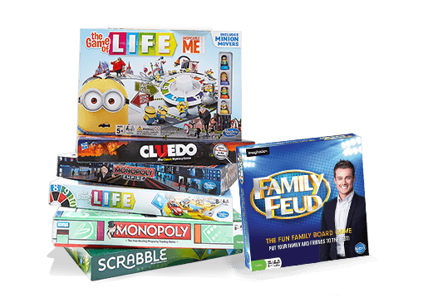
- Bath – Have a bath with your favourite soap in the bath to help you relax. Or make your own bath bomb, check online for recipes.
https://diyprojectsforteens.com/diy-bath-bombs-recipe/

- Board games – Play board games and trivia with your family. Bring out your old games you used to love when you were younger! Or you can purchase more online to be delivered to your house.

- Brain Teasers – Engage in brain teasers with the family! https://www.riddlesandanswers.com/tag/brain-teasers-for-teens/

- Build a Lego city - Find your Lego blocks and create a whole city. Use your family dog or cat as the oversized villain. Film your pet destroying the city. Or play Lego online: https://kids.poki.com/en/lego

- Card games – Play or learn new card games. Look up new card game ideas online.
Or play card games online: http://www.cardgamesolitaire.com/

- Chalk art - Chalk art can also be fun for teens and not just for kids. Create an elaborate masterpiece on your driveway, and join the Rainbow Trail Australia, a series of rainbow art being created around our communities at the moment: https://www.facebook.com/groups/214708792935275/
- Charades – Play charades with your family: https://ourpastimes.com/charade-ideas-teenagers-8725678.html

- Chat in real life - Have discussions with your family daily. Keep the lines of communication open, always, but especially during these times.

- Cleanup – It’s time to declutter, clean and organize your bedroom. Have a think about how you would like to re-organise your room and sort through any items you no longer need, keep them aside to donate or sell later.
- Clothing update - Go through clothing from previous seasons, try on and cull things that are too small, think about what you could donate, pass on or sell at a later date.
- Cloud watching – Lie on a rug in the garden and watch clouds go by. See if you can make shapes, animals, people etc out of the clouds.
- Chores – Help your parents/carers by assisting with a designated chore list, ticking off different chores each day.

- Dancing – Learn a new style of dancing from Youtube. Have fun!
- DIY Projects for Teens: https://diyprojectsforteens.com/

- Draw – Draw cartoons, pictures, a self-portrait etc. Learn how to draw from online tutorials: https://www.kidspot.com.au/things-to-do/collection/magic-tricks
- Exercise – Download a fitness app or watch fitness videos on YouTube including Yoga, Pilates, Cardio etc.
- Facetime friends and family – It’s good to be social, even if it is virtual for the time being.
- Family history - How about chatting about the family tree while sharing family history?
- Gardening – Pull weeds, trim bushes, plant a seedling, collect flowers for a vase. Ask your parents/carers how you can help in the garden.

- Go outside – Head into your backyard, kick the footy/soccer ball, play basketball, jump on the trampoline, lift small weights, jog around the yard, count your steps for the day and compete with others about who can do the most steps each day.
- Healthy eating – think about some new recipes you could eat to ensure a healthy diet, this will provide your body with good nutrients. Perhaps you could research a good smoothie recipe, salads, veggie dishes etc. Share your recipes with your friends!
- Homework – Keep up to date with homework that’s required. Check in with your teachers about your work and let them know if you need support.
- Inspirational quote – Choose one or two that you love and create a poster for your room.
- Indoor planting kit – Grow your own flowers, herbs, veggies in the comfort of your own home.

Journal – A journal can be helpful to write down your thoughts and feelings while being indoors. It is also a great reflection tool in that you will be able to read about your experiences in years to come and you could pass your journal on to other family members for them to read. You could document what you did each day, the best memory of the day, what you ate, anything new that you learned and what you are grateful for.

Karaoke – Have fun doing Karaoke with your family.

Knitting – Learn to finger knit, french knit or braid wool into friendship bracelets. You can learn more from YouTube clips etc.

Language – Learn a new language online.

Learn a new skill – Ask your parents/carers what skills they have that they could teach you. perhaps it was a skill that their parent taught them, e.g. sewing, learning how to cook a new recipe, plant a flower, calligraphy.

Magic tricks – Learn how to do magic tricks, search for ideas online.
- https://www.thesprucecrafts.com/magic-tricks-for-beginners-and-kids-2267083
- https://www.kidspot.com.au/things-to-do/collection/magic-tricks

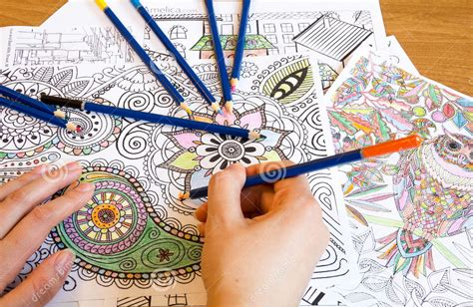
Mindful Coloring - Coloring books can help with anxiety and stress. Look up free mindful colour worksheets online.
- Mindfulness – Engage in mindfulness or meditation. Try lying down with your eyes closed, palms up and while focusing on your breath. Or you could utilise some of the apps suggested in our other tipsheet. Or download worksheets here: https://mindfulnessexercises.com/free-mindfulness-worksheets
- Movie night - Host a movie night with your family. Rotate each family member’s favourite movies or watch a new movie. Now is the perfect time to catch up on those really long movies you have avoided. Create a Google document of the movies you’ve watched and share it with friends.
Watch uplifting or hopeful movies, such as these movies: https://www.crosswalk.com/culture/features/hope-filled-movies-to-while-youre-stuck-in-the-house.html

Music – Listen to your favourite music, make a playlist. Dance around to fun beats too, whether oldies-but-goodies or something new, it's a great way to have everyone relax, laugh and get moving. Here are 100 songs that can uplift you during this time: https://www.usatoday.com/story/entertainment/music/2020/03/20/coronavirus-100-songs-listen-while-youre-stuck-at-home/2882725001/

Nails – Choose your favourite colour and paint your finger/toe nails.
- Name Word Games - Take the first letter of the first name of each group member and create words starting with that letter which also contain the letters I and N in that order later in the word. (Other letter combinations such as E and D can be chosen) Example: If one player's name is David, then examples of possible words would be: Darling, Duckling, Dancing.

Paint - Got paper and paint? Have a painting hour by yourself or with your family. You can learn new techniques through YouTube painting tutorials.

Pets – It’s a great time to spend time with your pets, teach them new tricks!

Picnic – Have a picnic lunch outside. Take books and music with you.

Photos – Look through old photo albums and recall old memories and stories together as a family.

Photography – Similar to journaling, you could document your time inside with a photo each day that represents what you did for the day. You can print your photos and place them into a photo book, album or craft book to keep and add captions or stories to your photos.
- Play instruments – Practice your flute, piano, trumpet etc.

Podcasts - Sit together and listen to podcasts, pick a few to listen to that you can learn from, be inspired by or relax to. Share with your friends.

Poetry – Write a poem. Or gather some tips on how to write poems, search online or try: https://poets.org/poetry-teens

Positive News – Make a point of sharing news that is positive from around the world, rather than focusing on the Corona Virus. Share your favourite stories you’ve read together over dinner. These webpages provide good inspiration such as:
https://www.goodnewsnetwork.org/
https://thenewdaily.com.au/news/good-news/
https://www.upworthy.com/
https://www.sunnyskyz.com/good-news

Puzzle – Complete puzzles together as a family or by yourself. Purchase puzzles online or even complete puzzles online: https://thejigsawpuzzles.com/

Reading – Read your favourite books, or books for class. Or you could order books online, such as: https://www.fishpond.com.au/ or https://www.booktopia.com.au/
- Scrapbooking - Create a scrapbook - Print your favorite photos of your family, your pets or friends. Assemble them in a scrapbook complete with stickers, captions and other embellishments.

- Selfies – Take selfies with your siblings and family members, show your family members how to use photo apps, be silly and have a little fun!

- Sleep - Or take a nap!

- Slime – Learn how to make your own slime at home with your family: https://www.bbcgoodfood.com/howto/guide/how-make-slime
- Story of Your Lives Game – Family game; can you share a story about your life in sixty seconds or less? Allow a minute (use your phone to time) for each player to write down a funny version of the story of their life to read out loud to the group.
- Sunrise/Sunset – Find out the time the sun rises or sets tomorrow and set an alarm to watch the sunrise/set by yourself or with a family member.

Time capsule – Make a time capsule of this time to be opened in 10 years.

Typing – Learn how to touch type, see how fast you can type and how many words you can type accurately in a minute. For more information, try here:
https://www.lifewire.com/free-typing-lessons-1356656

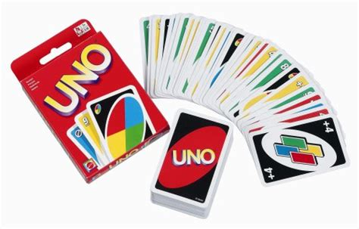
Uno – Play with your family, or play online: https://www.crazygames.com/game/uno-online

Unploug hour – Ensure one hour a day without accessing your phone, device or laptop. Use this as learning, reading or relaxing time.

Video – Put together a video of your favourite family videos and photos.

Virtual Tours – Visit different areas around the world through virtual tours! https://docs.google.com/document/d/1SvIdgTx9djKO6SjyvPDsoGlkgE3iExmi3qh2KRRku_w/preview

Vision Board – create a vision board with your favourite quotes and goals you’d like to achieve.

Weekly Menu – Help your parents/carer setup a weekly menu of what you can eat/cook for the week and how you can help.

Wish list - Write out a wish list of activities you want to enjoy once life gets back to normal. Make lists of all the museums, sporting events, places of interests and concerts you want to visit when they finally reopen.
- Write – Write out notes of love, compliments or drawings and hide them around the house for family to find.
- Write and direct a short film – Write and direct a film with your family. https://www.wikihow.com/Direct%2C-Act%2C-and-Create-a-Good-Movie-%28Kids-and-Teens%29
- Zoo – Go to the Melbourne Zoo, online! https://www.zoo.org.au/animal-house/
Or you could try the San Diego Zoo: https://animals.sandiegozoo.org/live-cams
Or visit the Online Zoo: http://theonlinezoo.com/

